W/ Friends
Meeting with friends:
- Pick a place to meet your friends
- See where your friends are going to go
- Personal/specific recommendations of places on the map like restaurants, landmarks etc for your friends also on the app.
- See their recommendations/ratings
- GPS system
- 6-digit code to add each other as friends (Later on a QR code can be added to manage friend requests)
- Secure log in page
- Two factor authentication?
- Chat with people in proximity.

Name Ideas:
- StalkMe
- StalkMyFriends
- FindMyFriends X
- FriendsDeck
- FriendCheck
- ThisIsMyLocation
- Where you at? X
- StalkR
- Stalking
- ImHere!
- AirFriends
- Not spyware
- Finder XXXXXX
- Friendprevent
- w/ friends Xxxxxx
- The Friend Zone
- FriendsLocator
- Friender
- Avoid.Me

Languages:
- Html, CSS, JavaScript, Php, SQL
- Java, python

Must have:
- Website
- Gps
- Register/Login
- DB (SQL)
- Manage Friends
- Meeting Room
- Friend Codes (6 Digit)
- FAQ
- Policies
- Manage Account
- Maps

Should have:
- 2FA
- Manage Friends (Add,Delete)
- Meeting Point on the Map
- Recommendations
Could have:
- Editing Friends
- Messaging (Group,Direct,Broadcast)
- Date of the meeting point
- QR Friend Code
- Mobile App
- Directions

Tasks:
Create site map (Mick & Davey) 60 min
Wireframes (Jim, Kenan, Marieke, Brandon) 90 min
Setup server (Jakub, Marly) 120 min
Research cybersecurity (Michael, Mick, Liam, Lux) all day
ERD, class diagram (Daan, Marly)
Mood board (Marieke, Davy, Brandon) 60 min

User stories
- As a visitor I want to look at the policies
- As a visitor I want to look at the FAQ
- As visitor I want to register
- As user I want to login
- As user I want to add friends
- As a user I want to manage friends
- As a user I want to delete friends
- As a user I want to access my account information/settings
- As a user I want to change my information
- As a user I want to change my email
- As a user I want to change my password
- As a user I want to see where my friends are
- As a user I want to recommend locations
- As a user I want to make meeting locations
- As a user I want to secure my account with 2FA
- As a user I want to look at the policies
- As a user I want to look at the FAQ
- As a user I want to enable my GPS
In this situation the user just logged in and is directed straight to the home page. From the home page you can see the map and all the other pages are in the navigation bar such as “Friends, Account Settings, FAQ, Policy, Logout”
In the FAQ page you can read through all the common questions and answers. The navigation will be at the top like usual with the following navigation buttons such as “Home, Friends, Account Settings, Policy, Login/logout”. You can access this page if you either logged in or as a new user.
In the Policy page you can see all of the agreements such as legal documents (GDPR) or TOS (Terms of Services), etc. The navigation will be at the top like usual with the following navigation buttons such as “Home, Friends, Account Settings, Policy, Login/logout”. You can access this page in any situation, so you don’t have to be logged in.
To change your email address and password you have to go click on the button called “Account Settings”. After you enter the input box you press “Confirm Edit”.
If you want to create an account, you navigate to the Login Page. Below the login input boxes you can see a button called “Register”. There you will enter a username, email, password and confirm password. After you have entered all the information you will have to agree to the TOS and click “Make Account”.
If you want to login from the home page you press the “Login” button and you are redirected to the login page. You can then enter your username and password in the text boxes. Finally, press the “Login” button and you will be taken back to the home page while being logged in.
If you want to see where your friends are, make sure to navigate to the home page to see the map. On this map you can see a circle with your friends username on it with their current location.
If you want to delete an account go to the account settings page. At the bottom page you will see a button that says “Delete account”. A pop up will appear confirming that you want to delete the account and click “Confirm” to delete your account or click “Cancel” if you change your mind.

Possible Logo:


Pages:
- Login/Register
- Home page (Navbar, footer for policy, FAQ, etc)
- Navbar, footer for policy, FAQ, etc (present on all pages)
- FAQ
- Policy
- Friends
- Settings (account management)

FAQ:
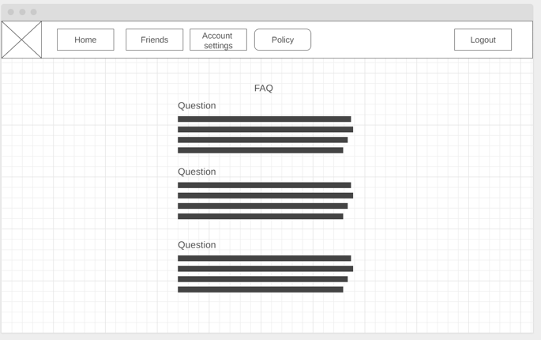
Policy:
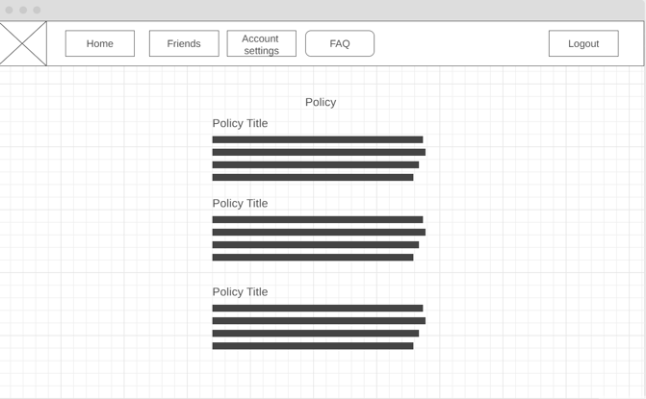
Account settings:
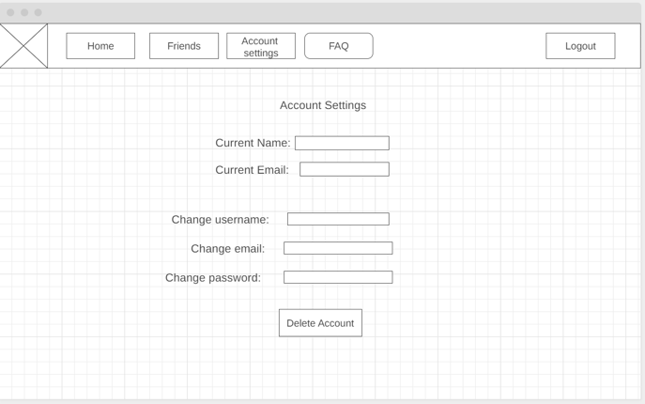

Research cybersecurity:

